Objective questions and their answers

- What is the total no. of tables present in the data?
Ans. There are two tables in the data i.e.raw_data table and
country_description table.

2. What is the total no. of attributes present in the data?
Ans. There are 20 attributes in the raw_data and 2 in the country_description initially.Now the raw_data has 27 attributes.
3. How many categorical columns are there in the data?
Ans. There are 15 categorical columns in the data. These are :
1. CountryCode
2. City
3. Country
4. Locality
5. LocalityVerbose
6. Cuisines
7. Currency
8. Currency_symbol
9. Has_Table_booking
10. Has_Online_delivery
11. Is_delivering_now
12. Switch_to_order_menu
13. Price_range
14. Rating
15.Suggested_or_not
4.The data consists of some inconsistent and missing values so ensure that the data used for further analysis is cleaned.
Ans.1. No duplicate rows were found in the dataset.
2.Extracted currency symbol from currency column using text to column function.
3.The data consists of some missing values in longitude,latitude and votes column, but I left it as it is because it would not affect my analysis. Also, we can’t fill the longitude and latitude with mean,median and mode.
4.There were some missing values in the cuisine column.So, I filled it manually with most popular cuisines because only 9 were missing.
5.Created a “customised_price” column that consists of currency symbol along with average cost for two people using concatenate function.Formula used “=CONCATENATE(M15,"",T15)”.
6.Converted average cost for two people in Indian rupees for better analysis.
- Searched for the value of currency for given countries in Indian rupees and noted that in the country_description table.
- Then using vlookup function fetched the value of currency from country_description table to raw_data table.Formula “=VLOOKUP(F2,'country description'!$E$2:$F$16,2,0)”.
- Multiplied the value with average cost for two people to convert in Indian rupees.Formula “=U2*W2”.

5.Using the LookUp functions, fill up the countries in the original data using the country code.

Ans.Inserted a column named “country” in the raw_data table and fetch the country name from country_description table using below formula:
=VLOOKUP(C2,'country description'!A:B,2,0).

6. Create a table to represent the number of restaurants opened in each country.

Ans. The bar chart given below represents the number of restaurants opened in each country and the pivot table is in sheet named Objective_Answer_6&7.

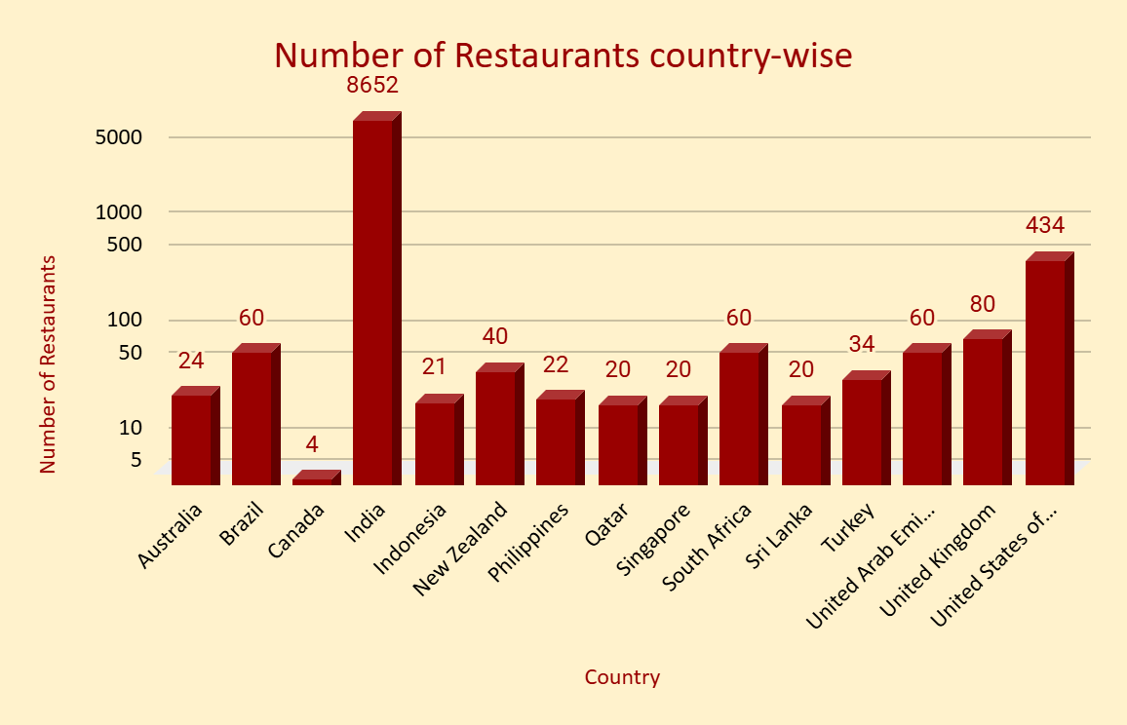

- India has the largest number of restaurants and Canada has the smallest number of restaurants.

7.Also, the management wants to look at the number of restaurants opened each year, so provide them with something here.

Ans.Made a pivot table and a chart for better visualization to look at the number of restaurants opened each year in each country.Pivot table is in “Objective_Answer_6&7” sheet.

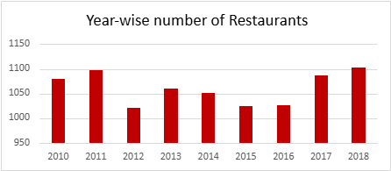

8. What is the total number of restaurants in India in the price range of 4?

Ans. There are 388 restaurants in India in the price range of 4.
Formula used “=COUNTIFS('Raw Data'!E:E,"India",'Raw Data'!R:R,4)”.

9. What is the average number of voters for the restaurants in each country according to the data?

Ans. According to the data the average number of voters for the restaurants in each country is shown in the chart below.
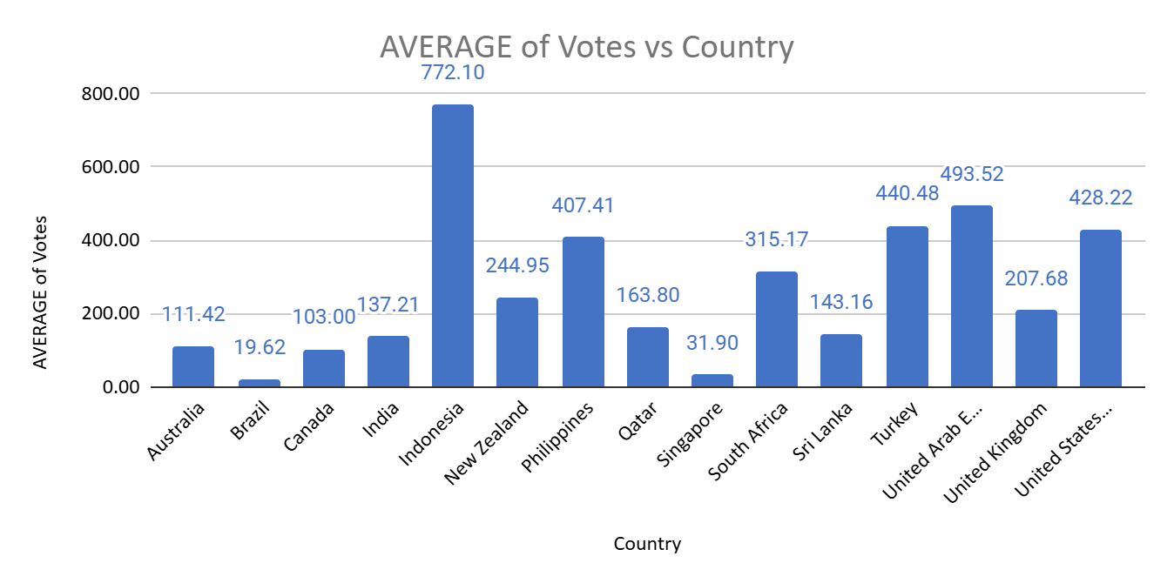
- Indonesia has the largest number of voters and Brazil has the lowest number of voters.

10. Calculate the average rating for all the restaurants that have price_range < 4 and provide online delivery. Use only the “IF” function, Logical Operators, and Aggregation functions to solve this problem.

Ans. The average rating for all the restaurants that have a price range less than 4 and provide online delivery is 3.27.

The formula used is “=ArrayFormula(AVERAGE(IF(('Raw Data'!R:R <4)*('Raw Data'!O:O="Yes"),'Raw Data'!W:W,"")))”.

11.Using Conditional formatting highlight the rows of restaurants that are located in the countries or cities that you’ve suggested to the management for opening new restaurants.

Ans. Following are the conditions which are considered for suggestion of places for opening new restaurants:
- Countries having restaurants < 100
- Restaurants with Ratings > 3
- Restaurants with Votes > 100
- Restaurants having average cost for two < 1500

Approach:

- Created a pivot table to find the number of restaurants in each country.

Country | Count of RestaurantID
Australia | 24
Brazil | 60
Canada | 4
India | 8652
Indonesia | 21
New Zealand | 40
Philippines | 22
Qatar | 20
Singapore | 20
South Africa | 60
Sri Lanka | 20
Turkey | 34
United Arab Emirates | 60
United Kingdom | 80
United States of America | 434
Grand Total | 9551

- For converting the average cost for two in Indian Rs.,I found the exchange rates for currencies of different countries on the internet.

- Multiplied the average_cost_for_two column with currency value in Indian rupees.

- Using filter function, applied filter on country column(selected all the countries except India and USA), rating column(used greater than > 3),votes column(greater than 100) and average cost for two in Rs.column (less than 1500).

- The filtered data was copied and pasted in the new sheet “Suggested_Places”.

- A new column “Suggested_or_not” was created in “Suggested_Places” sheet and filled with “suggested”.

- “Suggested_or_not” column was also created in raw_data sheet and fetched the values for this column from “Suggested_Places” sheet using vlookup and Ifna function.Formula used “ =IFNA(VLOOKUP($A2,Suggested_Places!A:AA,27,FALSE),"not")”

Based on these factors conditional formatting was done using this formula:
Format cells where a formula is true “=$AA2= “suggested” ”.

12.Create a new customized price column that consists of the abbreviation/symbol of the currency along with the Average_cost_for_two value.

Ans..Created a “customised_price” column that consists of currency symbol along with average cost for two people using concatenate function.Formula used “=CONCATENATE(M15,"",T15)”.

13. How can you create an array formula in Excel or Google Sheets to count the number of restaurants listed that do not offer online delivery, are in the lowest price range, and have an average cost for two people less than or equal to 250 Indian Rupees?

Ans. The number of restaurants that do not offer online delivery, are in the
lowest price range, and have an average cost for two people less than or
equal to 250 Indian Rupees is 1695.

Formula used for this calculation is “=ArrayFormula(COUNTIFS('Raw
Data'!O:O,"No",'Raw Data'!R:R,"<3",'Raw Data'!V:V,"<=250"))”.

Subjective questions and their answers

1. Suggest a few countries where the team can open newer restaurants with lesser competition. Which visualization/technique will you use here to justify the suggestions?

Ans.Following are the conditions which are considered for suggestion of places for opening new restaurants:
- Countries having restaurants < 100
- Restaurants with Ratings > 3
- Restaurants with Votes > 100
- Restaurants having average cost for two < 1500

Approach:

- Created a pivot table to find the number of restaurants in each country. Below chart represents the number of restaurants in each country.



- For converting the average cost for two in Indian Rs.,I found the exchange rates for currencies of different countries on the internet.

- Multiplied the average_cost_for_two column with currency value in Indian rupees.

- Using filter function, applied filter on country column(selected all the countries except India and USA), rating column(used greater than > 3),votes column(greater than 100) and average cost for two in Rs.column (less than 1500).

- The filtered data was copied and pasted in the new sheet “Suggested_Places”.

- Created Pivot tables of this extracted data and charts for better visualization in sheet named “Subjective_answers
_Pivot&Charts”.

Countries with lesser competition

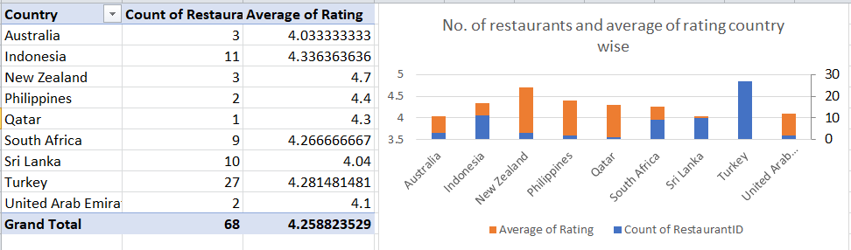

Insights and Recommendations:
Based on the report and visualization, some of the countries for opening newer restaurants can be:
- Australia
- Indonesia
- New Zealand
- Philippines
- Qatar
- South Africa
- Sri Lanka
- Turkey
- United Arab Emirates
2. Come up with the names of States and cities in the suggested countries suitable for opening restaurants.

Ans. Following are the conditions which are considered for suggestion of places for opening new restaurants:
- Countries having restaurants < 100
- Restaurants with Ratings > 3
- Restaurants with Votes > 100
- Restaurants having average cost for two < 1500

Approach:

- Created a pivot table to find the number of restaurants in each country.

- For converting the average cost for two in Indian Rs.,I found the exchange rates for currencies of different countries on the internet.

- Multiplied the average_cost_for_two column with currency value in Indian rupees.

- Using filter function, applied filter on country column(selected all the countries except India and USA), rating column(used greater than > 3),votes column(greater than 100) and average cost for two in Rs.column (less than 1500).

- The filtered data was copied and pasted in the new sheet “Suggested_Places”.

- Created Pivot tables of this extracted data and charts for better visualization in sheet named “Subjective_answers
_Pivot&Charts”.

Cities in suggested countries
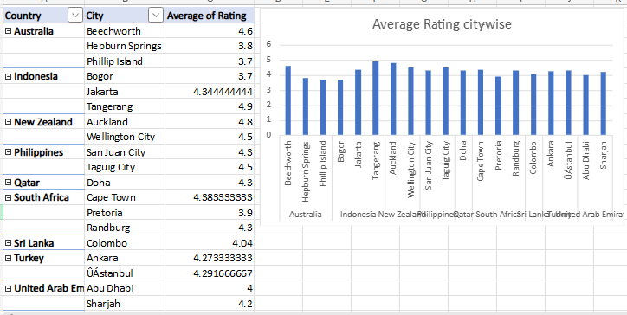
Insights:

- All the cities in the suggested countries have an average rating >3.5.
- The highest rated city is Tangerang of Indonesia i.e. 4.9.
- The least rated cities are Phillip Island of Australia and Bogor of Indonesia i.e. 3.7.

Recommendations:

All the cities have good ratings but Tangerang of Indonesia, Aucland of New Zealand and Beechworth of Australia are the highest rated cities.

3.According to the countries you suggested, what is the current quality regarding ratings for restaurants that are open there?

Ans. Following are the conditions which are considered for suggestion of places for opening new restaurants:
- Countries having restaurants < 100
- Restaurants with Ratings > 3
- Restaurants with Votes > 100
- Restaurants having average cost for two < 1500

Approach:

- Created a pivot table to find the number of restaurants in each country.

- For converting the average cost for two in Indian Rs.,I found the exchange rates for currencies of different countries on the internet.

- Multiplied the average_cost_for_two column with currency value in Indian rupees.

- Using filter function, applied filter on country column(selected all the countries except India and USA), rating column(used greater than > 3),votes column(greater than 100) and average cost for two in Rs.column (less than 1500).

- The filtered data was copied and pasted in the new sheet “Suggested_Places”.

- Created Pivot tables of this extracted data and charts for better visualization in sheet named “Subjective_answers
_Pivot&charts”.

Ratings in suggested cities


Insights:

- All the cities in the suggested countries have an average rating >3.5.
- The highest rated city is Tangerang of Indonesia i.e. 4.9.
- The least rated cities are Phillip Island of Australia and Bogor of Indonesia i.e. 3.7.

Recommendations:

All the cities have good ratings but Tangerang of Indonesia, Aucland of New Zealand and Beechworth of Australia are the highest rated cities.

4. Also, what is the current expenditure on food in the suggested countries, so we can keep our financial expenditure in control?

Ans.We can estimate the expenditure on food on the basis of average cost of dining for two people in the suggested countries.If the dining cost is less then the expenditure would also be less.

Following are the conditions which are considered for suggestion of places for opening new restaurants:
- Countries having restaurants < 100
- Restaurants with Ratings > 3
- Restaurants with Votes > 100
- Restaurants having average cost for two < 1500

Approach:

- Created a pivot table to find the number of restaurants in each country.

- For converting the average cost for two in Indian Rs.,I found the exchange rates for currencies of different countries on the internet.

- Multiplied the average_cost_for_two column with currency value in Indian rupees.

- Using filter function, applied filter on country column(selected all the countries except India and USA), rating column(used greater than > 3),votes column(greater than 100) and average cost for two in Rs.column (less than 1500).

- The filtered data was copied and pasted in the new sheet “Suggested_Places”.

- Created Pivot tables of this extracted data and charts for better visualization in sheet named “Subjective_answers
_Pivot&charts”.

Average expenditure on food in suggested countries

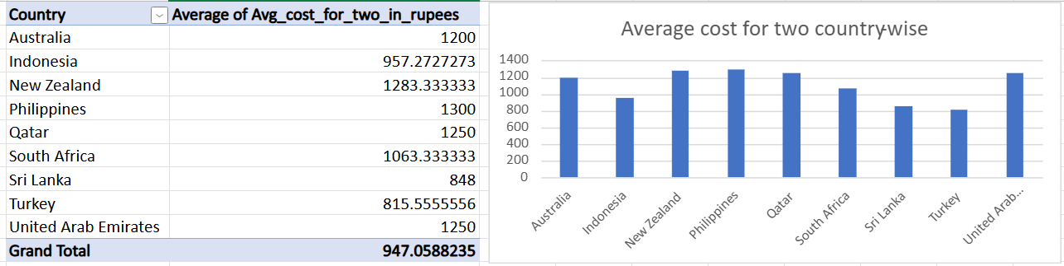

Insights:

- The Philippines is the most expensive country in terms of expenditure on food i.e. 1300 INR.
- Sri Lanka is the least expensive country in terms of expenditure on food i.e. 848 INR.

Recommendations:

Expenditure on food is different in every country.Among the shortlisted countries,Sri Lanka is the least expensive country and Philippines is the most expensive country.So based on this team can set the pricing of food and estimate the average expenditure.

5. Come up with the names of restaurants from the recommended states that are our biggest competitors and also those that are rated in the lower brackets, i.e. 1-2 or 2-3.

Ans. Following are the conditions which are considered for suggestion of places for opening new restaurants:
- Countries having restaurants < 100
- Restaurants with Ratings > 3
- Restaurants with Votes > 100
- Restaurants having average cost for two < 1500

Approach:

- Created a pivot table to find the number of restaurants in each country.

- For converting the average cost for two in Indian Rs.,I found the exchange rates for currencies of different countries on the internet.

- Multiplied the average_cost_for_two column with currency value in Indian rupees.

- Using filter function, applied filter on country column(selected all the countries except India and USA), rating column(used greater than > 3),votes column(greater than 100) and average cost for two in Rs.column (less than 1500).

- The filtered data was copied and pasted in the new sheet “Suggested_Places”.

- Created Pivot tables of this extracted data and charts for better visualization in sheet named “Subjective_answers
_Pivot&charts”.

Note: All the suggested countries have an average rating of > 3.5.So, I am taking the following condition:
- Bigger competitor:Ratings > 4.2
- Smaller competitor:Ratings <= 4.2

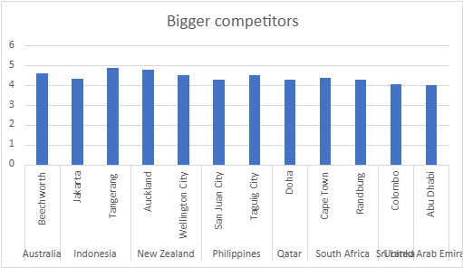

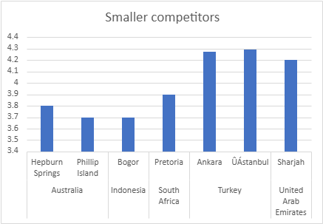

Insights:

- We have 12 bigger competitors and 7 smaller competitors.
- Tangerang of Indonesia is our biggest competitor.
- Phillip Island of Australia and Bogor of Indonesia is our smallest competitors.
Recommendations:

- I recommend opening new restaurants in areas with smaller competitors, allowing for easier market penetration and growth.
- Alternatively, strategically opening restaurants in areas dominated by bigger competitors can help Zomato gain visibility and market share in high-demand locations.

6. Which cuisines should we focus on in the newer restaurants to get better feedback? Does the choice of cuisines affect the restaurant ratings?

Ans. Following are the conditions which are considered for suggestion of places for opening new restaurants:
- Countries having restaurants < 100
- Restaurants with Ratings > 3
- Restaurants with Votes > 100
- Restaurants having average cost for two < 1500

Approach:

- Created a pivot table to find the number of restaurants in each country.

- For converting the average cost for two in Indian Rs.,I found the exchange rates for currencies of different countries on the internet.

- Multiplied the average_cost_for_two column with currency value in Indian rupees.

- Using filter function, applied filter on country column(selected all the countries except India and USA), rating column(used greater than > 3),votes column(greater than 100) and average cost for two in Rs.column (less than 1500).

- The filtered data was copied and pasted in the new sheet “Suggested_Places”.

- To find the top rated cuisines, I have taken all restaurants data from raw_data sheet and made a pivot table and a chart in the Subjective_answers_Pivot&charts sheet.

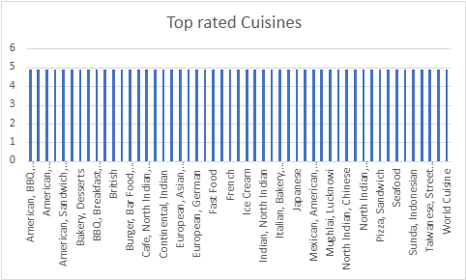

Insights and Recommendations:

Following cuisines are highly appreciated and top rated:
- American, BBQ, Sandwich
- American, Burger, Grill
- American, Coffee and Tea
- Cafe, North Indian, Chinese
- Burger, Bar Food, Steak

We should offer these cuisines in our new restaurant for better customer feedback.

7. According to our current data, should we go for online delivery and table booking? Does that affect the customer’s ratings?

Ans. Following are the conditions which are considered for suggestion of places for opening new restaurants:
- Countries having restaurants < 100
- Restaurants with Ratings > 3
- Restaurants with Votes > 100
- Restaurants having average cost for two < 1500

Approach:

I have taken all restaurants data from raw_data sheet for better analysis of table booking and online delivery.

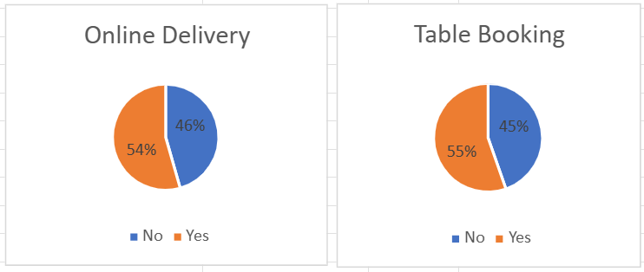

Insights:

Yes, it affects the customer ratings.Ratings are higher for the services of online delivery and table booking.

Recommendations:

We should definitely go with table booking and online delivery for better customer feedback.

8. Should the team keep the rate of cuisines higher? Will that affect the
feedback? According to our data are the rates of cuisines and ratings,
correlated?

Ans. Approach:I have taken all restaurants data from raw_data sheet to get a better understanding of rates of cuisines and their ratings.
Created a pivot table and a chart for better visualization in the sheet Subjective_answers_Pivot&charts.
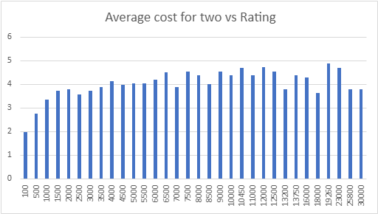
Insight:

- Cuisines with low prices do not have good ratings.
- Cuisines with medium rates have ratings around 4.3.
- Moreover,the correlation-coefficient of price and rating is 0.352.

Recommendations:

We should keep the rates of our cuisines medium for better customer ratings and feedback.

9. What is the distribution of the number of restaurants of different price
ranges in all the countries?

Ans. Following are the conditions which are considered for suggestion of places for opening new restaurants:
- Countries having restaurants < 100
- Restaurants with Ratings > 3
- Restaurants with Votes > 100
- Restaurants having average cost for two < 1500

Approach:

I have taken all restaurants data from raw_data sheet to analyze the number of restaurants in all price ranges.Created a pivot table and a chart in the sheet Subjective_answers_Pivot&charts.

The below chart represents the distribution of the number of restaurants of different price ranges in all countries.

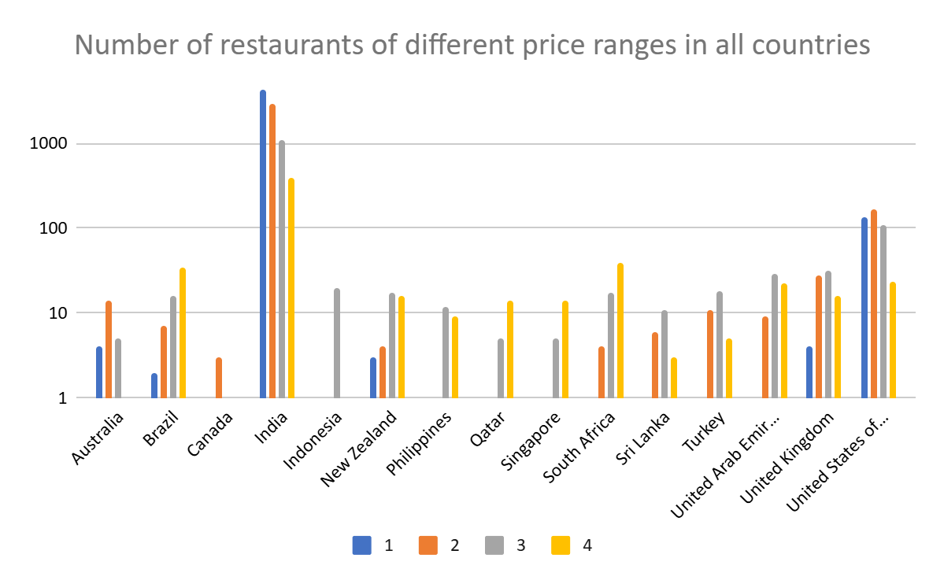

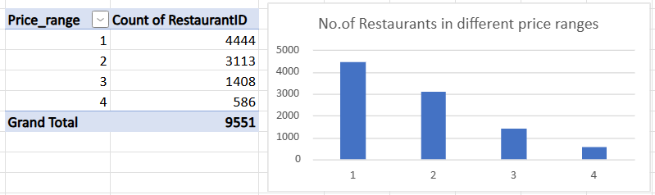

Insights:

- The highest number of restaurants fall in the lowest price range(1).
- Number of restaurants with the maximum price range(4) is the lowest.

However, in the suggested countries when we remove India and USA, it is observed that:
- Only a few restaurants have the lowest price range(1).
- Number of restaurants with the medium price range(3) is high.

Recommendations:

We should focus on the medium price range i.e.3.

10. Explain your approach in brief for suggesting countries/cities in order to open new restaurants, if the objective and subjective questions would have not been given to assist you. [you have to give bullet pointers in order to answer this question]

Ans. Here's my approach to suggesting countries/cities for opening new restaurants without objective and subjective questions:

Market Analysis:

- Research global food delivery markets to identify trends, growth rates, and competition.
- Analyze demographic data, such as population size, age, and income levels.
- Examine market saturation and demand for food delivery services.

Geographic Expansion

- Identify regions with high population density, urbanization, and economic growth.
- Consider countries with a strong food culture, diverse cuisine, and demand for international food options.
- Look for cities with a high concentration of offices, universities, and residential areas.

Competitor Analysis

- Research existing food delivery companies, their market share, and expansion strategies.
- Analyze competitors' strengths, weaknesses, and market gaps.
- Identify opportunities to differentiate and innovate in the market.

Data-Driven Insights

- Utilize data analytics tools to analyze market trends, customer behavior, and competitor activity.
- Leverage data to identify opportunities, optimize operations, and measure performance.

By considering these factors, I can provide data-driven suggestions for countries and cities that are well-suited for opening new restaurants.

